Giving Event User Manual

This manual provides step-by-step instruction on how to setup a giving event quickly (website and mobile) . For ease of understanding, screenshots have been attached.
Step 1: Login as a RazAdmin and go to Admin page
Step 2: Click on Brands -> New. Create a new Brand using the below inputs,

  - Subdomain
  - Name.

Fill Form:

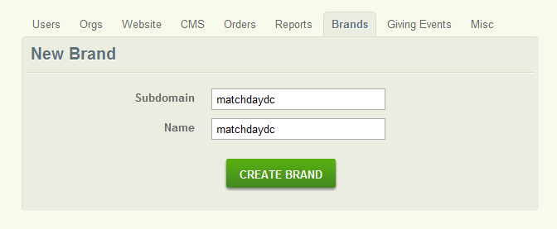

After Creation:

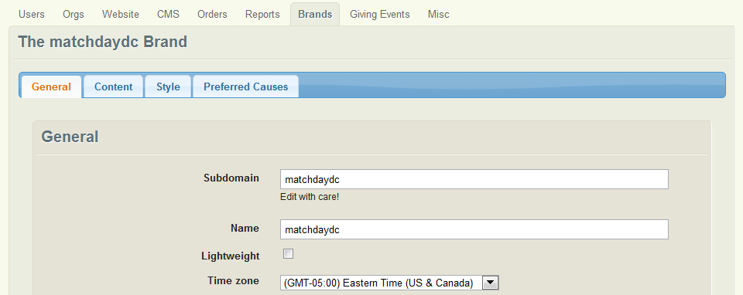

- Check “Lightweight”, “Allow Stored Cards”, “Enable mobile redirect” and Save Changes.
- To direct the user to the mobile version of the Giving site, ask Will to do a redirect that redirects from “www.macthdaydc.razoo.com” to “www.matchdaydc.razoo.com/giving_events/MatchDayDC/home”

Step 3: Upload the valid non-duplicate preferred causes through Brand Edit screen

Before uploading preferred causes list, this is how the search page will look:
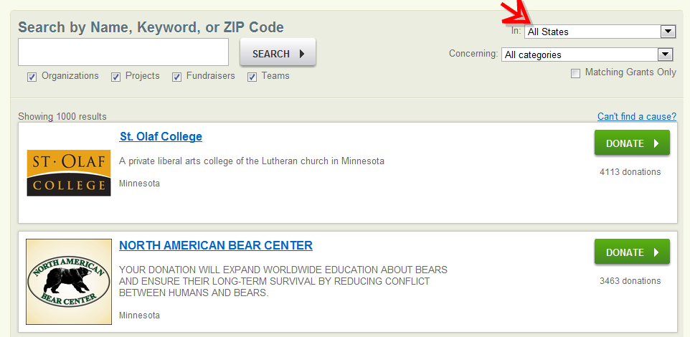
Upload preferred causes .csv file (URN’s or EIN’s)

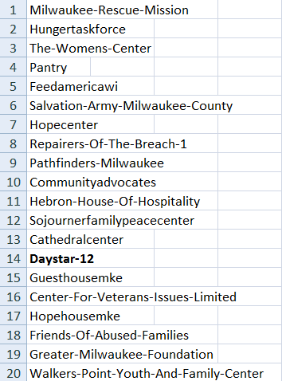
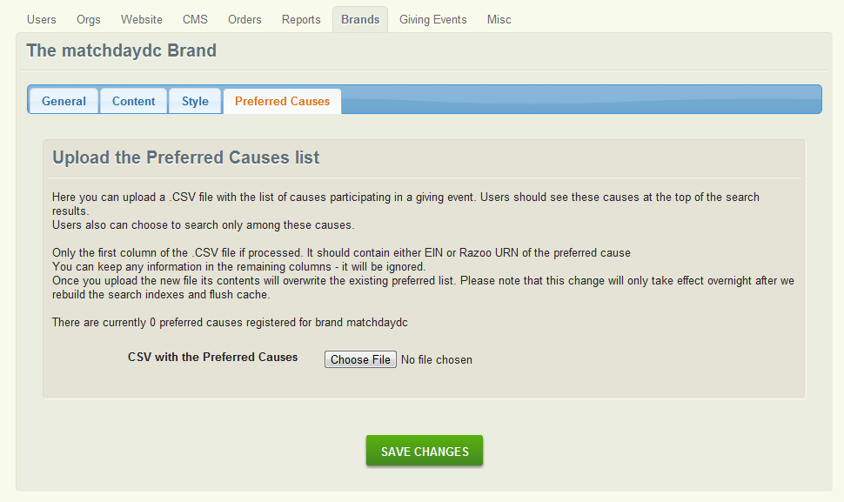

After uploading preferred causes:

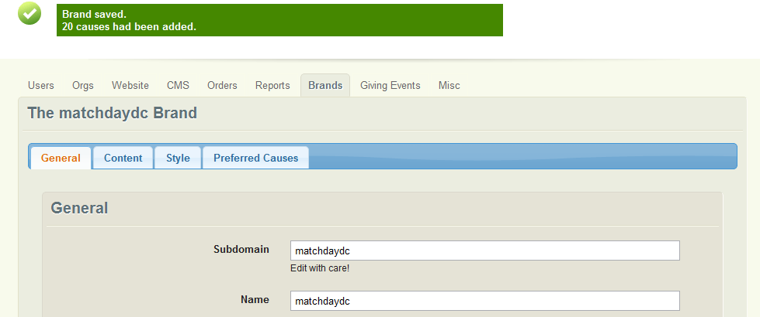

After uploading preferred causes list, the search page will have “matchdaydc Causes Only” Checkbox and it will be checked by default

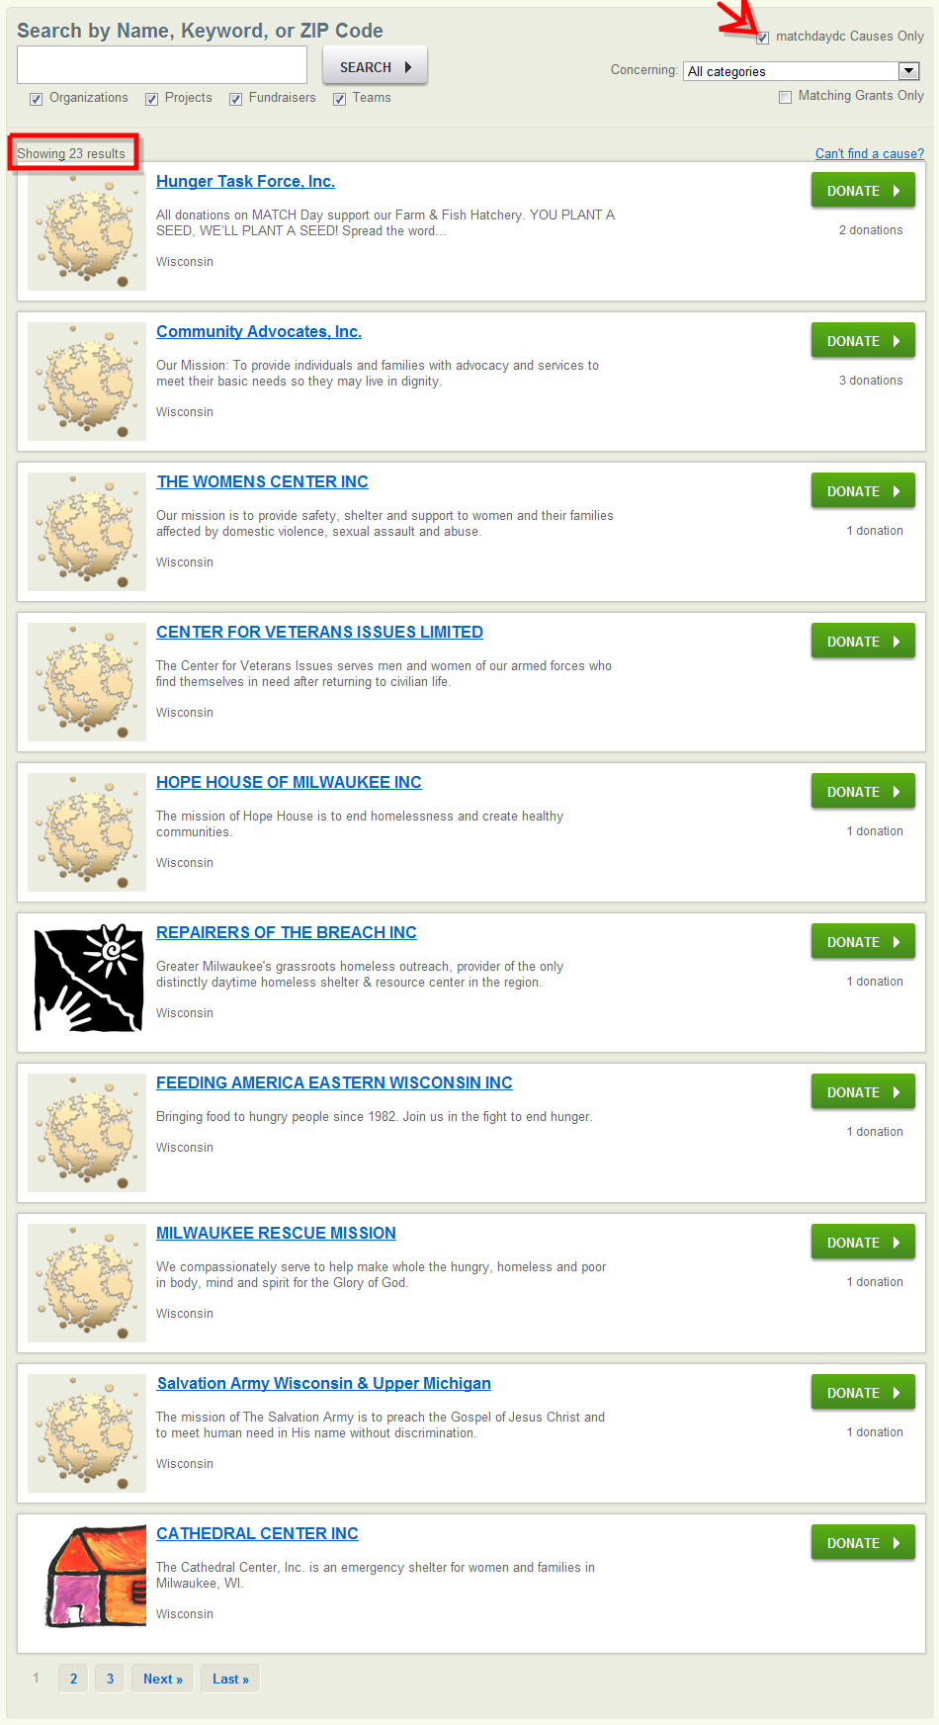

Step 4: Click on Giving Events -> New. Create a Giving Event using the below inputs

  - Name
  - Key
  - Start date
  - End date
  - Show 'Schedule Donations' Starting (Optional)
  - Notification Emails (Mandatory. Used for Golden Tickets. Even if the giving event does not require golden ticket, we still require an email address. We want to do this because when the giving event really has golden tickets and we do not provide an email id, notification will not be sent. So, it should be a mandatory field so that the user is alerted)
  - Facebook Branding: When set, the image and the message will appear on Facebook when a user posts to Facebook.

Create Giving Event.

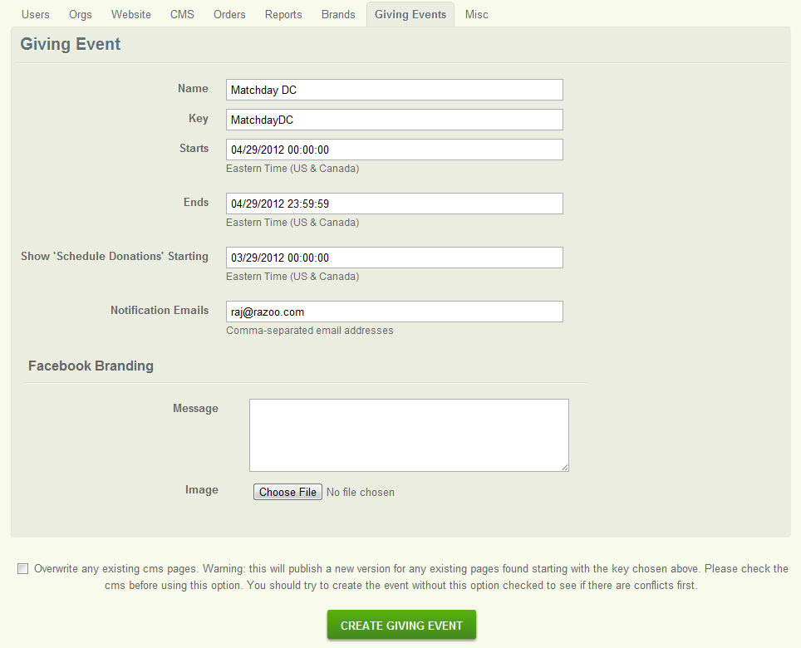
After creation of Giving Event: Once the giving event is created, 23 CMS pages get created automatically that can be used by the design team to design the giving event website.

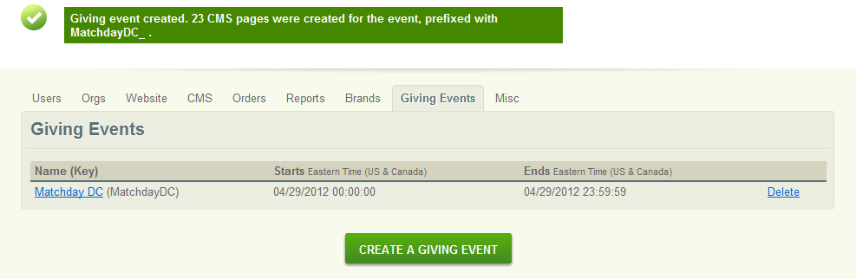

23 CMS pages:

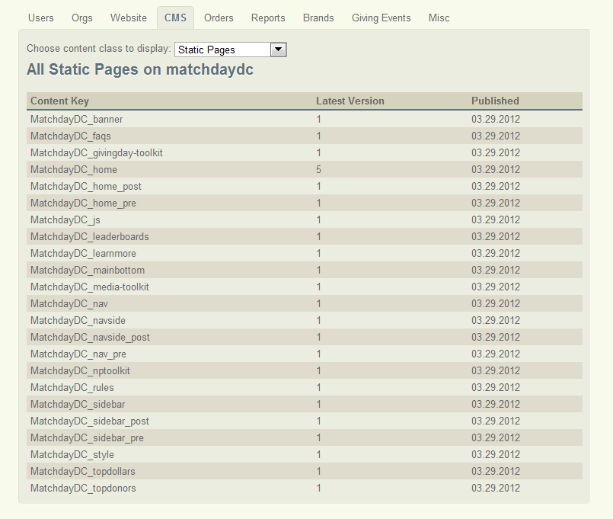
When the giving event was created, the “Show Schedule Donations Starting’ was set to March 29 2012 and the giving event start and end date was set to April 29 2012. So all story pages on the giving site will have a link (“Schedule one for Matchday DC”) that will allow users to schedule a donations from March 29 2012 00:00:00 – April 28 2012 23:59:59. On April 29 2012 00:00:00, this schedule donation link will disappear from all the story pages.

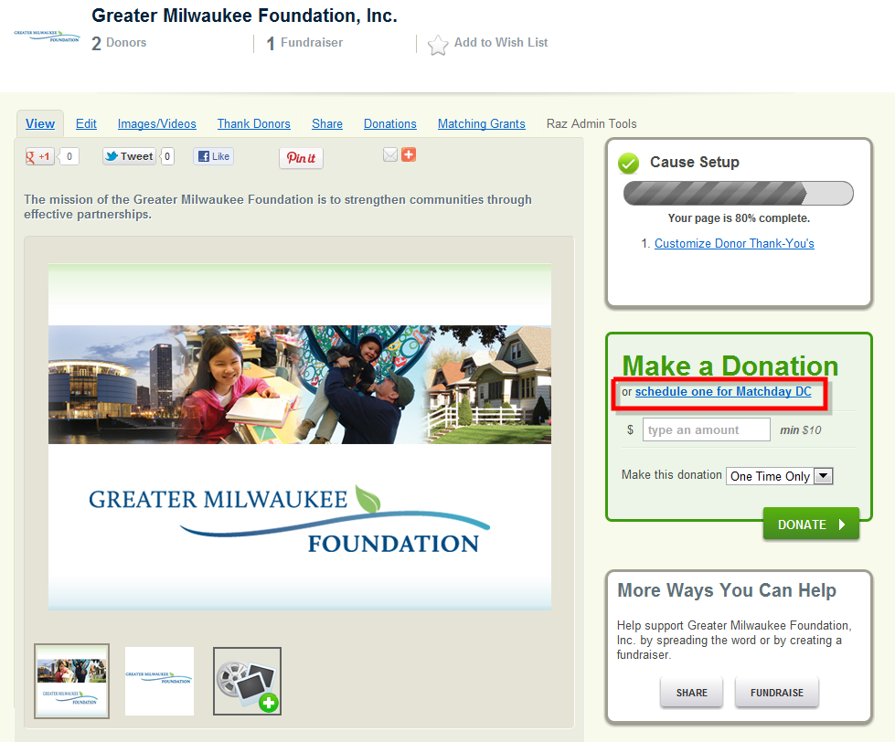

Step 5: Go to Orgs -> Leaderboard2 and click on “Create Leaderboard” button.

Create a leaderboard using the below inputs
- Name
- Start at
- End at

Optional Items:

Referral Code

This should be used If the giving event requires donations to be tracked by referral code.

Order Source

Tracking donations can be done from any of the following sources: Any (includes mobile, razoo sites), Razoo Sites, Mobile

PS: Though you can see donation widget as one of the option, referral code doesn’t work with Donation widget. It will be implemented later.

Create Giving Event Leaderboard:

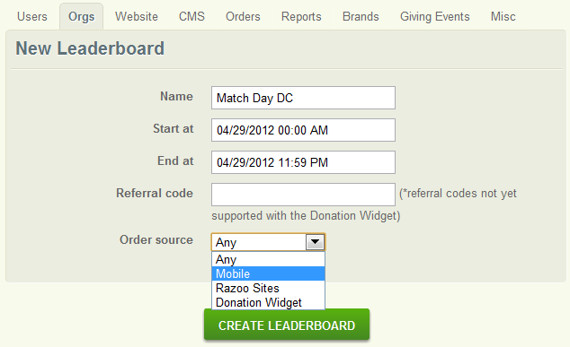
Add Entries to the Leaderboard using one of the below options

- Add Entries section (Type in URNS or EINs comma-separated)
- Upload the preferred causes .csv file

Click “Save”. If any of the causes needs to be removed, add the EIN/URN (comma-separated) of the causes and click on “Save”. A success/fail message will be displayed to the user if they entries were removed or not.

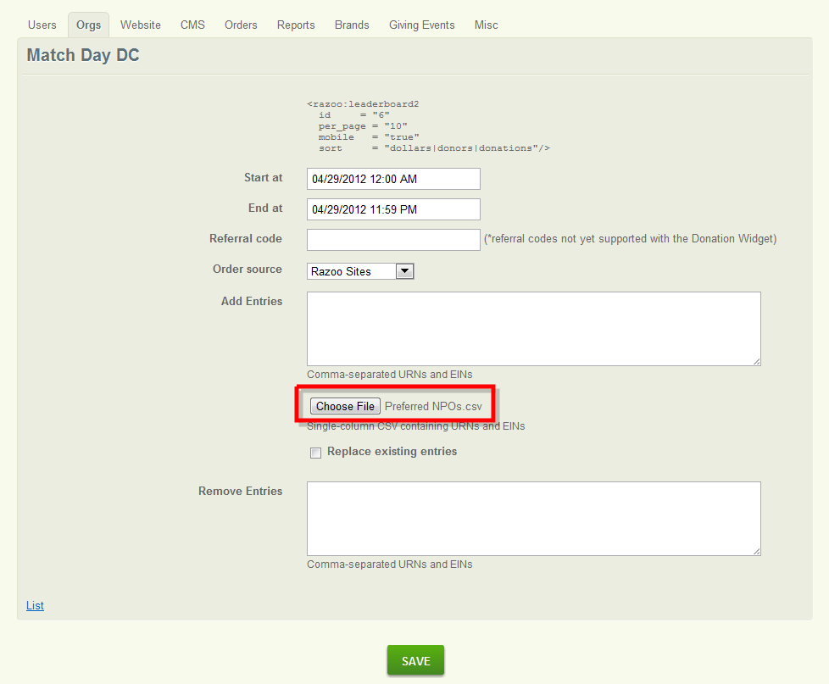

Step 6: Go to the CMS page list and click on “MatchDayDC_home”. Populate the home page with Leaderboard and giving totals.

The below radius tags need to be used for displaying a leaderboard and giving totals on the home page
Leaderboard:
<razoo:leaderboard2
id = "6"
mobile = "true/false"
pagination = “true/false”
per_page = “10”
sort = "dollars"/>

Giving Totals
<razoo:giving_event:countdown />
<razoo:giving_event:total_dollars />
<razoo:giving_event:total_donors />
<razoo:giving_event:total_donations />
<razoo:giving_event:total_receiving_npos />

Hit “Save Changes“->”Close this Version (Done Editing)”. Finally hit, “Publish this version”

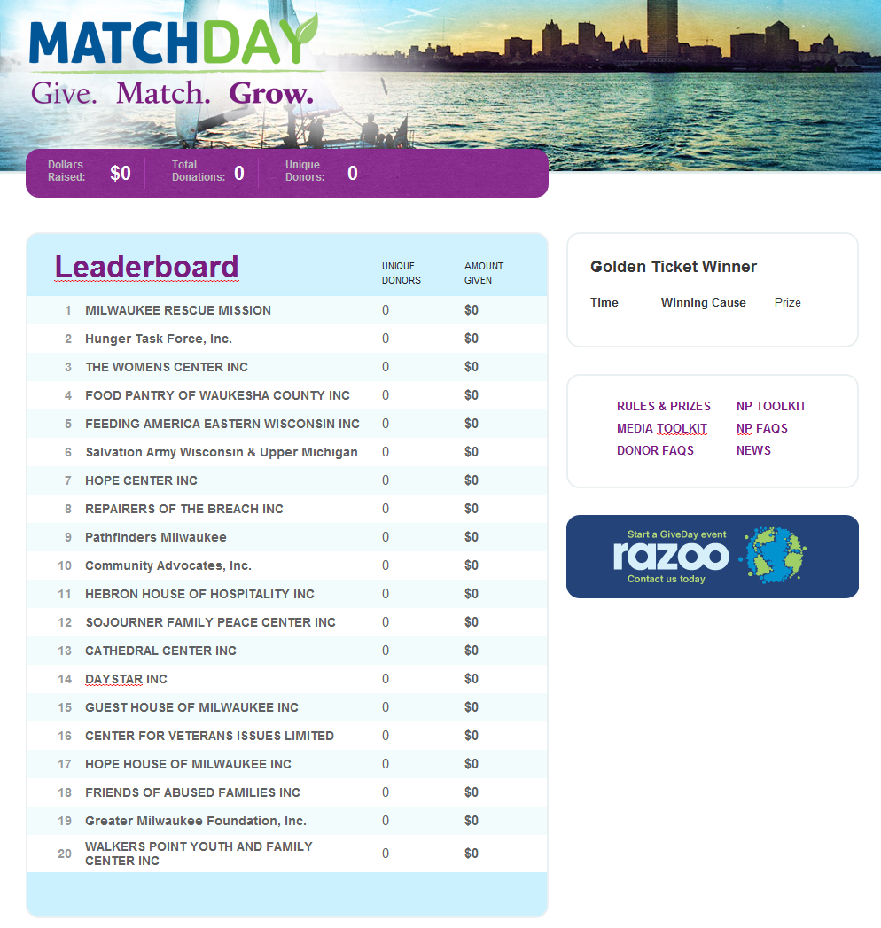
Step 7 (Optional): Go to Giving Events -> List -> Select the giving event from the list. Scroll to the bottom to the Golden Ticket Section. Click “New Golden Ticket” Link

You will find the below options
  - Type
  - Prize money
  - End date
The golden ticket winner can be picked based on 3 types: Dollar, Donor, Random

Dollar Type: NPO that received the highest donation amount for that particular period (if there is a tie, then we pick the first donation)

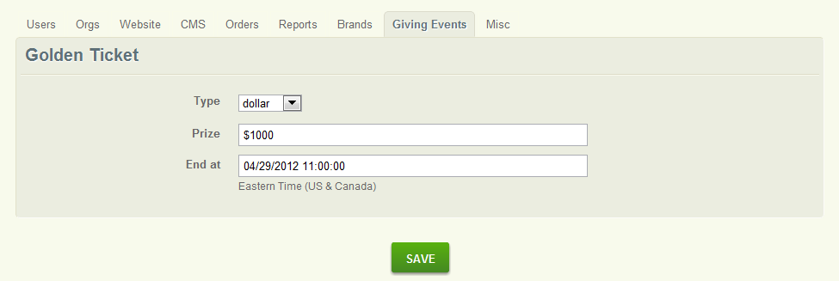

After Creation:

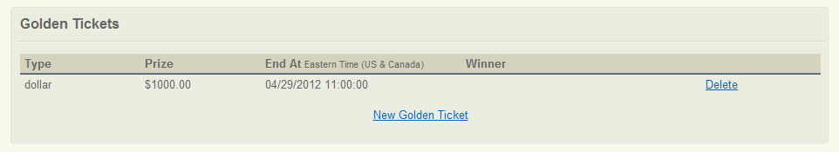

Donor Type: NPO that received the highest number of unique donors

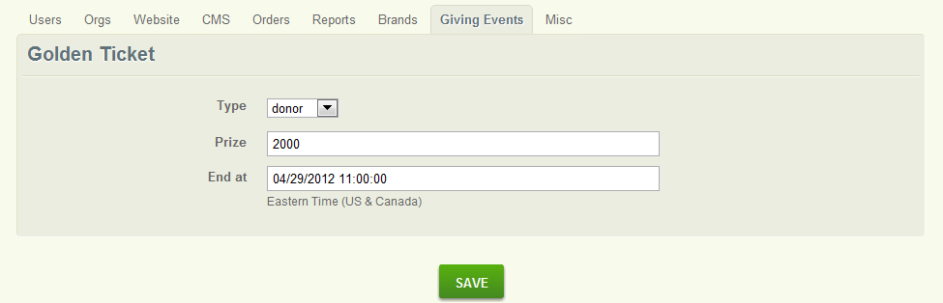

After Creation:

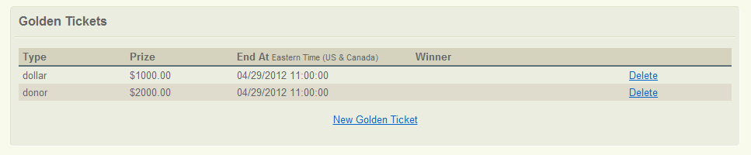

Random Type: Random donation will be chosen from the given time period and its corresponding NPO is considered to be the winner. Anonymous donor will not be considered.

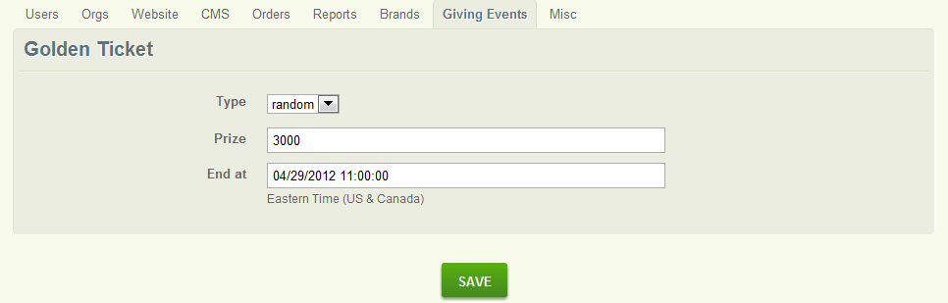

After creation:

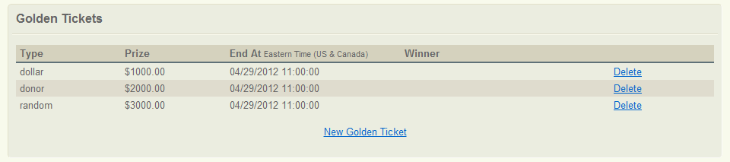

Post-Giving Event To Do List:
- Update the total with MG amount (If there are matching grants associated with the giving event)
- Update the total with Offline amount, if any (If there are offline donations associated with the giving event)
- Update the total with Prize amount ((If there are prize amounts associated with the giving event)
- Ask Engineering team to make the home page static.
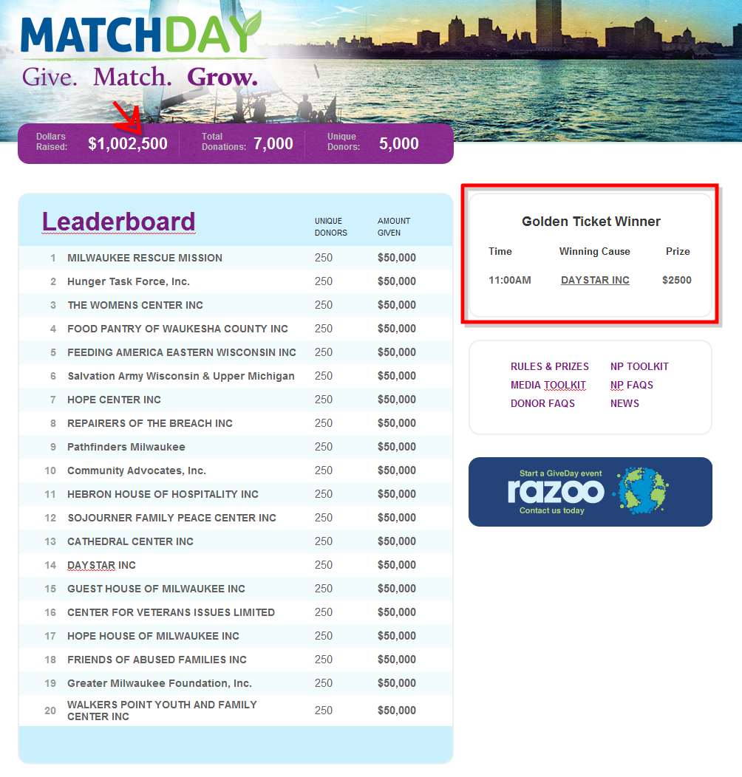
Mobile Site Setup

Pre-Condition:
- Make sure “Mobile Redirect” checkbox is checked on the “Edit Brand” Admin screen so that the user is directed to the mobile optimized site.
- To direct the user to the mobile version of the Giving site, ask Will to do a redirect that redirects from “www.macthdaydc.razoo.com” to “www.matchdaydc.razoo.com/giving_events/MatchDayDC/home”
CMS Content for the mobile giving site:
The mobile content on the following CMS pages need to be setup for the mobile version of the giving site. There is default content that is displayed in the mobile content area that needs to be tweaked for our requirements.
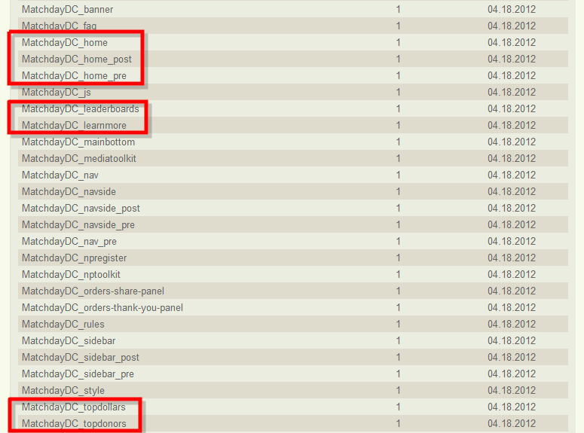
- MatchDayDC_home_pre – This content will be displayed before the giving event begins
CMS page:
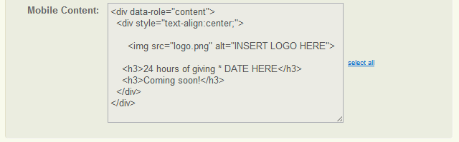

Mobile:
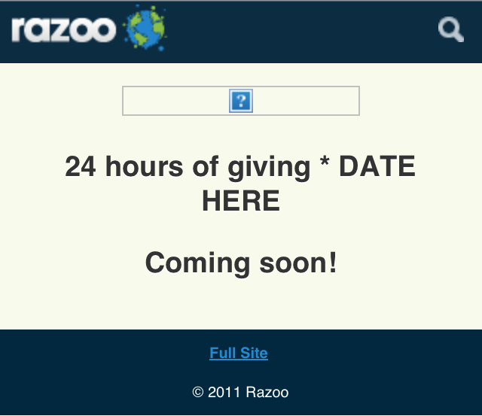
- MatchDayDC_home – This content will be displayed when the giving event has started
CMS page:
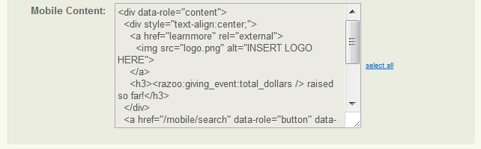
Mobile:
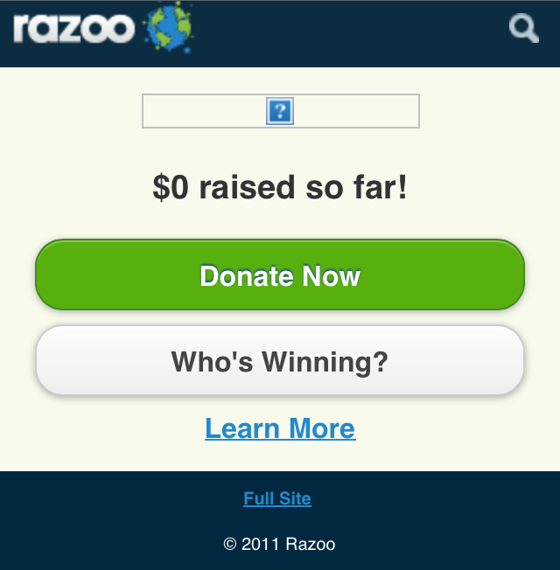
- MatchDayDC_home_post – This content will be displayed after the giving event
CMS page:
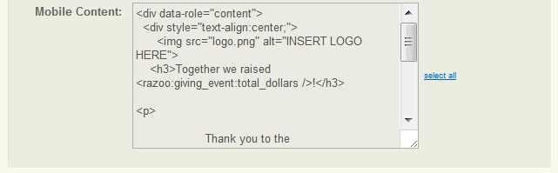

Mobile:
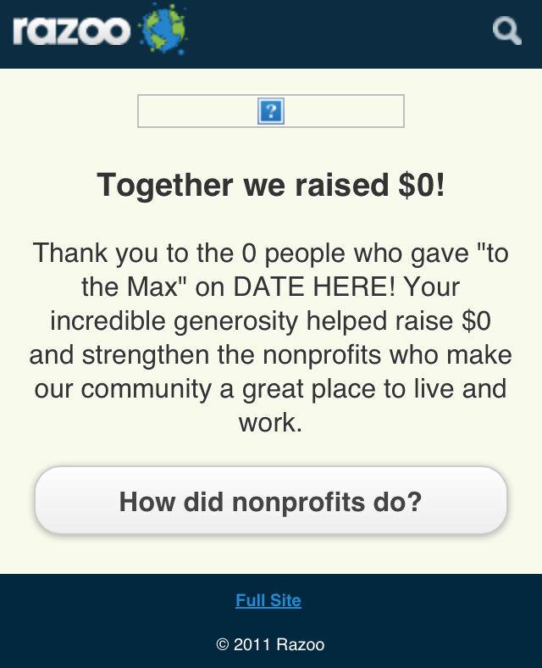
- MatchDayDC_leaderboards - Displays a page with the leaderboard
CMS page:
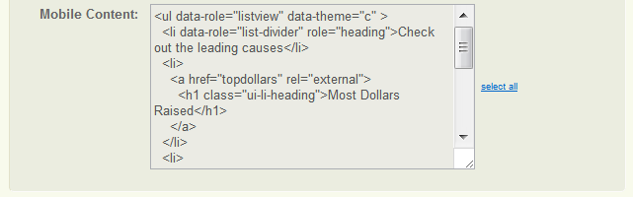
Mobile:
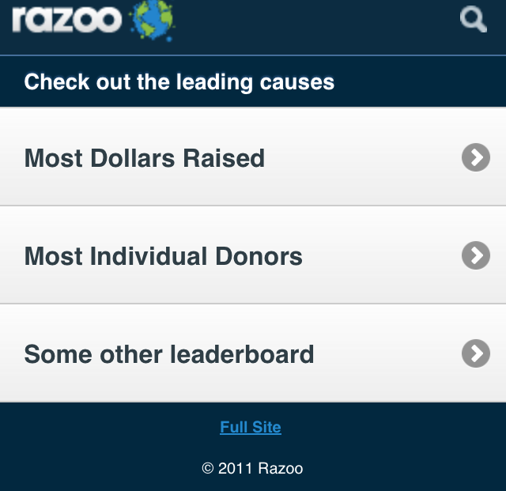

- MatchDayDC_topdollars – Most Dollars Raised Leaderboard
CMS page:
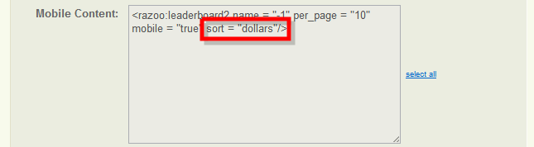
- MatchDayDC_topdonors – Most Individual Donors Leaderboard
CMS page:
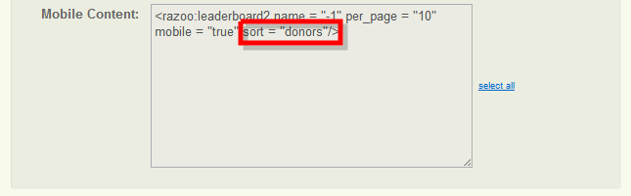
- MatchDayDC_learnmore – For more information on the giving event like “Find and Give”, “Who’s winning?”
CMS page:
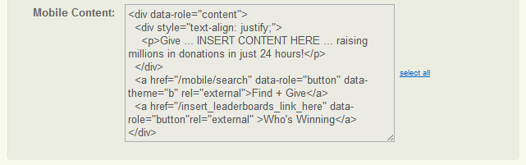
Mobile:
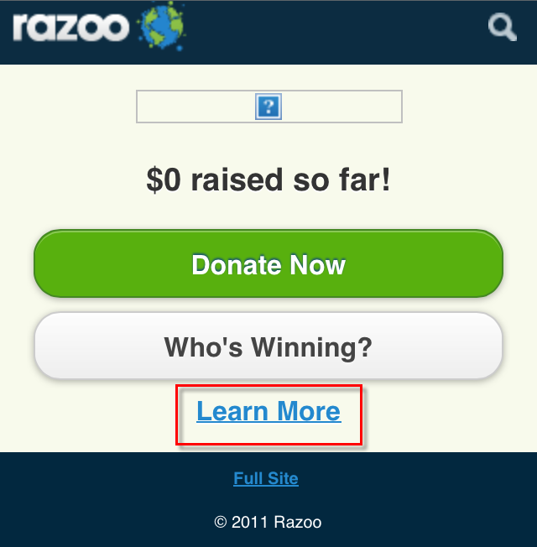
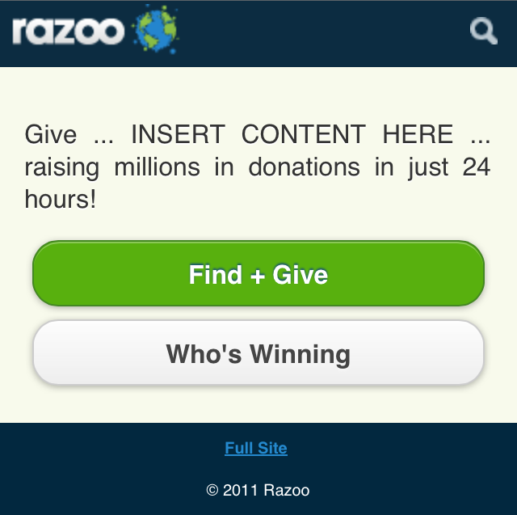

- MatchDayDC_orders-thank-you-panel - This content will only be displayed on the mobile post donation thank you page if the giving event is active and this CMS page is published.
Not part of Stage (Release 2.5).

The logo for the giving event needs to the uploaded and the path should be referenced in all the CMS pages that use the logo.

